Frontend Sprint Plan (Step by Step)

🟢 Frontend Sprint 1: Setup & Base UI
Goal: App opens in browser with basic layout
Tasks:
- Create React project
- Setup folder structure
- Setup routing
- Create base layout (Header, Footer)
- Environment config for backend URL
Deliverables:
- App runs on localhost:5173 or 3000
- Home page loads
- Routing works
Why:
This gives a foundation so features can be added without rework.

Frontend Sprint 2: Authentication (Login / Register)
Goal: User can register & login
Tasks:
- Register page UI
- Login page UI
- Connect to /api/users/register
- Connect to /api/users/login
- Store user data (localStorage)
Deliverables:
- User registers from UI
- User logs in successfully
- Error messages shown properly
Why:
Auth is needed before cart, orders, and profile.

Frontend Sprint 3: Product Listing (Core Kirana Feature)
Goal: Show products like Blinkit
Tasks:
- Product card component
- Product list page
- Category filters
- Search bar
- API integration for products
Deliverables:
- Product grid visible
- Categories clickable
- Search works
Why:
This is the heart of a Kirana app.

Frontend Sprint 4: Cart & Quantity Management
Goal: Add items to cart
Tasks:
- Add to cart button
- Increase / decrease quantity
- Cart page
- Cart state management
Deliverables:
- Cart updates live
- Total price shown
- Items persist till refresh
Why:
Without cart, there is no commerce.

Frontend Sprint 5: Checkout & Address
Goal: Place an order
Tasks:
- Address form
- Order summary
- Place order API
- Order success page
Deliverables:
- Order placed successfully
- Order ID returned
Why:
This completes the buying flow.

Frontend Sprint 6: Profile & Orders
Goal: User account management
Tasks:
- Profile page
- Order history page
- Logout
Deliverables:
- User sees past orders
- Profile data visible

Frontend Sprint 7: Admin Panel (Optional but Powerful)
Goal: Manage Kirana store
Tasks:
- Admin login
- Add/update products
- Manage orders
Why:
Makes your project job-ready & interview-ready.

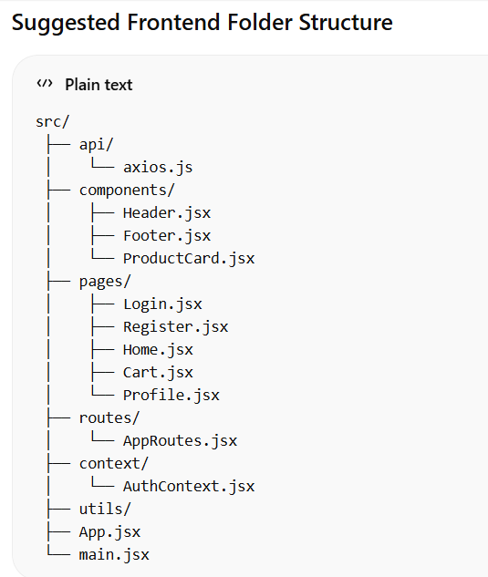

CORS error :
Your browser has a security rule:
A web page can only call APIs from the same origin
(same protocol + domain + port)
If it doesn’t match, the browser blocks it.

What is an origin?
Example:
- Frontend: http://localhost:5173
- Backend: http://localhost:8080
These are different origins because the port is different.
Even though both are on your machine, the browser still blocks it.

What problem you were hitting (your exact case)
You open your Kirana frontend in the browser.
Then React tries to call:
http://localhost:8080/api/users/login
Browser says:
I don’t know if this backend is safe.
Backend did not say it allows requests from localhost:5173.
So the browser blocks the response.
Backend may even be working, but browser hides it.
That is the CORS error you saw.

Console error: Access to fetch at 'http://localhost:8080/health'
from origin 'http://localhost:5173' has been blocked by CORS policy

What OPTIONS request is (important)
Before sending POST/PUT/DELETE, browser sends:
OPTIONS /api/users/login
This asks:
“Backend, are you okay with this request?”
If backend blocks OPTIONS → CORS fails.

What happens if we don’t add CORS
- Frontend sprints fail
- Auth APIs fail
- Products won’t load
- Cart won’t work
- Everything looks broken even though backend is correct
CORS is a foundation, not a feature.

When CORS is NOT needed
- Backend to backend communication
- Postman calls
- Curl commands
- Mobile apps (Android / iOS)
CORS is browser-only security.

